
A 10

Sreenidhi Institute of Science & Technology
(An Autonomous Institution)
Code No: 101EC08/111EC08

B. TECH. III – Year II – Semester Examinations, MAY, 2014 (Regular,Supple.)
SIGNALS & SYSTEMS ( EEE )

Time: 3 Hours Max. Marks : 70

Note : No additional answer sheets will be provided.

Part-A (Objective Type)
Max.Marks:20

Answer all QUESTIONS.
- Find out the energy of the signal x(t)=e^{-3t}u(t).
- Why the mean square error criterion and not the average error criterion is chosen for minimizing the error over an interval.
- Show that if the Fourier Transform (FT) of x (t) is X(ω), then FT of .
- Show that using duality (or similarity) property of FTs.
- Find out the LT of x(t) = 3e ^{-2t} u(t) – 2e ^{-t} u(t) and sketch the ROC in s- plane .
- When does aliasing occur? How can it be avoided?
- If X(z) =2+3z⁻¹+4z⁻². Find the initial and final values of the corresponding sequence x(n).
- What is power spectral density.
- Define auto correlation function and mention its properties.
- State sampling theorem for bandpass signals.

Part – B
Max. Marks: 50

ANSWER ANY FIVE QUESTIONS. EACH QUESTION CARRIES 10 MARKS.

- Distinguish between power and energy signals. Determine the total energy of the raised-cosine pulse x(t), shown in Fig.1 defined by:
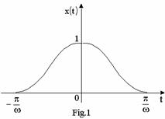
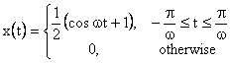
- Determine the time domain signal x(t) whose FT is shown in Fig.2.
Fig.2
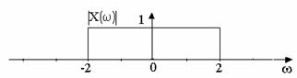

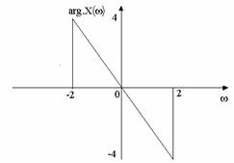

- Obtain Laplace Transform of the signal.
- Consider an LTI system with input x(n) and the unit impulse response h(n)specified as: x(n) = 2 n u(-n) and h(n) =u(n). Determine y(n).
- Explain the concept of
(i) Non-linear phase (ii) Group delay
(iii) Continuous-time ideal low pass filter (iv) First – order continuous –time system.
- Define sampling and aliasing. For a signal x(t), calculate Nyquist rate and Nyquist interval. x (t) = 3cos 50πt + 10 sin300πt – cos100πt.
- Consider a sinusoidal signal with random phase designed by
x(t)= A ; Where A and f_{c} are constant and is a random variable that is uniformly distributed over the interval [, ], i.e
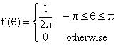
Find (i) Auto correlation function of x(t).
(ii) Power spectral density of x(t).
- State and prove the initial and final value theorems in Laplace transform.

-- 00 -- 00 --

